Missouri Project Oversight Program

July 2002
Version: Initial Draft

Part II
Project Oversight Processes and Templates

Prepared by

State of Missouri
Office of information Technology (OIT)
Table of Contents

Part II: Project Oversight Processes, Templates, Reports 1
Project Oversight Methodology Introduction 1
Oversight Methodology Overview 2
Oversight Initiation Process 5
Oversight Planning Process 5
Oversight Implementation Process 6
Oversight Closeout Process 6
Oversight Vitality Process 7
CHAPTER 1: Oversight Initiation Process 8
Overview 8
Sub-Processes & Templates 8
Initial Oversight Level Qualification 9
Complete Oversight Level Questionnaire 12
Questionnaire Overview 13
Template Sections 13
Oversight Level Questionnaire 13
Project Information Analysis 18
Complete Project Information Template 20
Template Overview 22
Template Sections 22
Template Form Sample 22
contractually binding documentation 23
Non-Contractual Documentation 23
Project Information 23
Template Detail 24
Chapter 2: Oversight Planning Process 25
Overview 25
Sub-Processes & Templates 25
Develop Oversight Plan 26
Oversight Management Structure Matrix 28
Oversight Level 29
Description 29
Oversight Information Demand Matrix 29
Information Demand Characteristics Definitions 30
Complete Oversight Strategy Template 32
Oversight Strategy Template 33
Template Overview 33
Template Sections 33
Template Form Sample 33
Template Detail 34
Complete Project Oversight Plan Document 36
Build Oversight Project Model 38
Communicate Project Oversight 42
Chapter 3: Oversight Implementation Process 44
Overview 44
Sub-Processes & Templates 44
Monitor Deliverable Dependencies 45
Evaluate Deliverable Quality 47
Report Oversight Status 50
Complete Oversight Summary Report 53
Oversight Summary Report Example 56
Report Overview 56
Report Sections 56
Report Example 56
Report Detail 58
Complete Project Improvement Plan Template 59
Project Improvement Plan Template 61
Template Overview 61
Template Sections 61
Template Form Sample 61
Project Name 62
Problem Description 62
Problem Cause 62
Improvement Description 62
Submittal Date 62
Oversight Reviewer Comments 62
Review Date 62
Date Closed 62
Template Detail 63
Complete Oversight Issues Report 64
Oversight Issues Report Example 66
Report Overview 66
Report Sections 66
Report Example 66
Report Detail 70
Complete Oversight Projects Rollup Report 72
Oversight Projects Rollup Report Example 75
Report Overview 75
Report Sections 75
Report Example 75
Report Detail 76
Monitor Issues/Actions 78
Chapter 4: Oversight Closeout Process 81
Overview 81
Sub-Processes, Templates and Report Examples 81
Perform Project Closeout 82
Complete Process Improvement Report Template 84
Process Improvement Report Template 86
Template Overview 86
Template Sections 86
Template Form Sample 86
Project Name 87
Issue, Circumstances, Solution 87
Alternative Solutions 87
Process Improvement Description 87
Review Date 87
Approval Date 87
Template Detail 88
Appendix A – Baseline Oversight Model 89

Part II: Project Oversight Processes, Templates, Reports
Part II of the MPOP Manual, Project Oversight Processes, Templates and Reports, includes an overview of the project oversight methodology, the process models and detail for the oversight processes as well as specific templates and report examples used to manage and implement the project oversight methodology.

Project Oversight Methodology Introduction
An oversight program, by most definitions, is simply a high level auditing function where a set of processes are implemented to monitor, evaluate and report status. While these activities are certainly an important part of an oversight methodology, the only real benefit they provide is the dissemination of project status to stakeholders. They do little to help improve the projects probability of success. The Missouri Project Oversight Program (MPOP) has taken oversight one-step further. Instead of simply acting as a “watchdog” over the project, MPOP includes proactive strategies that allow the oversight processes to become an active influence on the success of the project.

A key benefit of MPOP is the support provided to the project manager. MPOP is in place to help keep the project manager focused on the critical path, help anticipate project needs, and allow the project manager to identify, prioritize, and address issues in a timely and effective manner. With this support, the chance of successful on-time and on-budget project implementation is significantly increased. It’s important to note that these added benefits would not be realized without a close, mutually beneficial relationship between the oversight manager and the project manager/project team. It is critical that the agency project manager perceives the MPOP processes as a benefit and not a hindrance. The processes and tools defined in this manual have been carefully designed with this perspective in mind.

The processes, tools and information contained within this manual have been implemented and refined on the CIMOR Project Oversight Pilot Project and proven to be effective in influencing positive outcomes on the project. However, the program is still in its infancy and has not been tested on all possible types of IT projects. It is expected that the program including the processes contained within will undergo additions, modifications, and deletions as lessons are learned during future applications of the methodology. This will ensure the vitality of the program as it adapts to the needs of various IT projects. The final MPOP oversight process, Oversight Closeout Process, is included for the primary purpose of facilitating this type of continuous process improvement.

It is important to remember that there are many factors that affect the successful completion of an IT project. Implementation of an oversight process does not guarantee success. In fact, on very small project oversight is more of an annoyance than a benefit. However, on larger, more complex projects, appropriate implementation of the project oversight methodology has proven to be of considerable value to Missouri. Implementing an oversight approach that combines project status assessment, monitoring, and reporting with the added value of high-level project manager support, allows the project manager to attack detail-level issues and tasks with confirmation that the overall project is on track. Project success becomes a team effort between the project team, the project manager and the oversight manager with the ultimate goal of increased IT system quality.

Oversight Methodology Overview
The Oversight Methodology processes, sub processes, templates, and associated narratives identified in this part enable the oversight manager to perform the function of project oversight to the benefit of Missouri’s IT initiatives. The processes covered in Project Oversight Manual Part II, Chapters 1 – 4 are provided in the order, which follows the natural flow of the oversight activities.

There are four primary processes:

- Oversight Initiation Process
- Oversight Planning Process
- Oversight Implementation Process
- Oversight Closeout Process

Associated IT management processes include:

- Project Management
- Missouri Value Assessment (TCO/ROI)
- Missouri Adaptive Enterprise Architecture (MAEA)

Major deliverables from these processes include:

- Oversight Project Model
- Oversight Summary Reports
- Project Improvement Plans
- Oversight Issues Reports
- Oversight Projects Rollup Report
- Process Improvement Reports

Documentation utilized by the processes include:

- Project Oversight Manual Part I and Part II
- Missouri Value Assessment Program (MVAP) Manual
- Missouri Adaptive Enterprise Architecture (MAEA) Manual Part II
- Project related documentation

Figure 1-1, Project Oversight Methodology Overview presents the four primary processes of the oversight methodology. The processes flow into each other in waterfall fashion starting with Oversight Initiation and ending with Oversight Closeout. The key element of the methodology is the Oversight Project Model (OPM). It is central to the entire methodology and its accurate reflection of the project is critical to successful project oversight. The initiation and planning processes are involved in producing the OPM and ensuring it closely models the project. The implementation process applies the OPM to the project and generates revisions to the OPM as project characteristics change. The closeout process generates potential process improvements for the overall oversight methodology. The MPOP Vitality Process is a proposed process that is yet to be determined. If developed, this process will involve the actual implementation of the process improvements. Through these processes, the methodology not only provides an increased probability of project success through its implementation, but also promotes it’s own improvement.

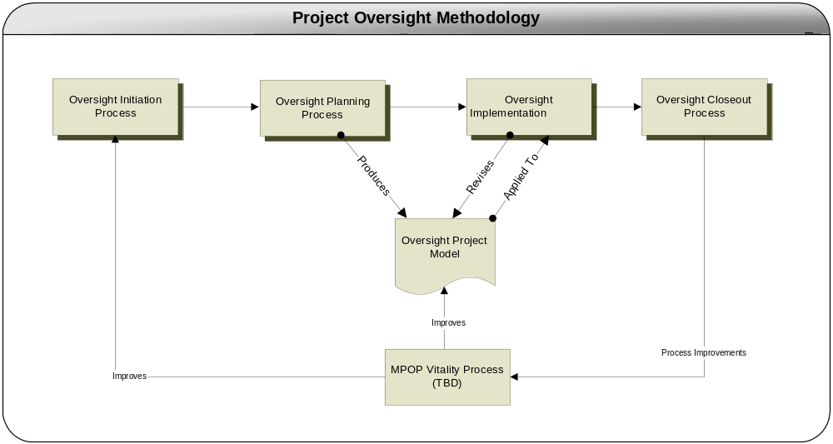

Figure 1-1, Project Oversight Methodology Overview

Each of these four primary processes is supported by a number of sub processes, templates and report examples that facilitate execution of the Project Oversight Program. Figure 1-2, Oversight Processes, Templates and Reports, identifies the sub processes, templates and report examples and their relationships.

Report Oversight Status
Complete Oversight Summary Report
Complete Project Improvement Plan Template
Complete Oversight Issues Report
Complete Oversight Projects Rollup Report
Oversight Summary Report Example

Oversight Issues Report Example

Project Improvement Plan Template

Oversight Projects Rollup Report Example

Monthly Oversight Review

Monitor Deliverable Dependencies
Ongoing Monitoring

Evaluate Deliverable Quality
Monitor Issues/ Actions
Implementation Process
Closeout Process
Perform Project Closeout
Complete Process Improvement Report Template
Process Improvement Report Template

Project Completion

Initiation Process
Planning Process
Initial Oversight Level Qualification
Project Information Analysis
Complete Project Information Template
Project Information Template

Project Initiation

Develop Oversight Plan
Complete Oversight Strategy Template
Complete Project Oversight Plan Document
Build Oversight Project Model
Communicate Project Oversight
Oversight Strategy Template

Project Oversight Model (OPM) Example

Oversight Plan Document Example

Vitality Process

(The Vitality Process is TBD at this time.)

Figure 1-2, Oversight Processes, Templates & Reports

The detailed process models and templates including associated narratives are presented in Chapters 1-4. The following provides a brief description of the five primary processes.

Oversight Initiation Process

The Oversight Initiation Process has the primary objective of ensuring that the oversight manager gains a strong understanding of the project and its potential risk areas. To make this possible this process includes the accumulation of project documentation that will be used throughout the life of the project. Included is an initial identification and analysis of critical project information, which results in an understanding of the project risks. The oversight methodology relies upon this information and analysis to identify and configure the oversight toolset. The Oversight Initiation Process is supported by a number of sub processes and templates. The sub processes and templates that support the Oversight Initiation Process are as follows:

Sub Processes

- Initial Oversight Level Qualification
- Project Information Analysis
- Complete Project Information Template

Templates

- Project Information Template

Oversight Planning Process

Planning is critical to the success of any endeavor and project oversight is no exception. The Oversight Planning Process starts with the development of an oversight strategy and an oversight plan, each of which are key products derived using the results of the analysis of project information obtained during the Oversight Initiation Process. It also involves perhaps the most important step of the methodology, development of the Oversight Project Model (OPM). The OPM is the key tool used during the Oversight Implementation Process. Finally all oversight information, tools, and plans are communicated to the project team and the oversight committee to ensure a clear understanding of the role that oversight will play during the project. The Oversight Planning Process is supported by a number of sub processes and templates. The sub processes and templates that support the Oversight Planning Process are as follows:

Sub Processes

- Develop Oversight Plan
- Complete Oversight Strategy Template
- Complete Project Oversight Plan Document
- Build Oversight Project Model
- Communicate Project Oversight

Templates

- Oversight Strategy Template

Oversight Implementation Process

The Oversight Implementation Process is the central process to the entire methodology. The implementation activities include the continuous monitoring of project performance, quality, and issues using the OPM. It also involves the reporting functions needed for communications of project health throughout the project lifecycle. The Oversight Implementation Process is supported by a number of sub processes and templates. The sub processes and templates that support the Oversight Implementation Process are as follows:

Sub Processes

- Monitor Deliverable Dependencies
- Evaluate Deliverable Quality
- Report Oversight Status
- Complete Oversight Summary Report
- Complete Project Improvement Plan Template
- Complete Oversight Issues Report
- Complete Oversight Projects Rollup Report
- Monitor Issues/Actions

Templates

- Project Improvement Plan Template

Oversight Closeout Process

The Oversight Closeout Process is the final process is performed after final system implementation and completion of the project. It is designed to promote constant process improvement primarily for the oversight methodology and the agency IT organization and processes. It is through beneficial changes in the oversight methodology that the Oversight Project Model will improve to more accurately reflect future projects and increase the oversight manager’s ability to impact quality for a project. The proposed MPOP Vitality Process is intended to define the processes for this purpose

The closeout process may also provide potential improvements to other Missouri IT program such as Risk Management, Project Management, etc. Through continuous improvement to Missouri’s IT programs, the quality of Missouri’s IT systems should also improve. The sub processes and templates that support the Oversight Closeout Process are as follows:

Sub Processes

- Perform Project Closeout
- Complete Process Improvement Template

Templates

- Process Improvement Template

Oversight Vitality Process

The Oversight Vitality Process is required to maintain the vitality of the Missouri Project Oversight Program. The Project Oversight Manager generates process improvement reports that need to be addressed by the program. Additionally, programmed and external trigger events to the vitality process need to be accommodated to ensure the continued viability of the program. At this time, the Project Oversight Program Vitality Process has been recognized but not defined. Completion and incorporation into the Project Oversight Program is targeted for future addition to the program.

CHAPTER 1: Oversight Initiation Process
This chapter provides a description of all processes, templates and report examples that are part of the Oversight Initiation Process. This process is a precursor to the Oversight Planning Process.

Overview

The oversight initiation process is comprised of steps that are performed as a precursor to the applied project oversight activities. It provides critical information needed to gain insight into the project and prepare project oversight tools. The sub-processes include:

- Initial Oversight Level Qualification
- Project Information Analysis
- Complete Project Information Template

Sub-Processes & Templates

Each of the sub-processes follows the same format:

Sub-Process
Process Model
Process Detail
Template (if applicable)
Overview
Sections
Sample Template Form
Template Detail

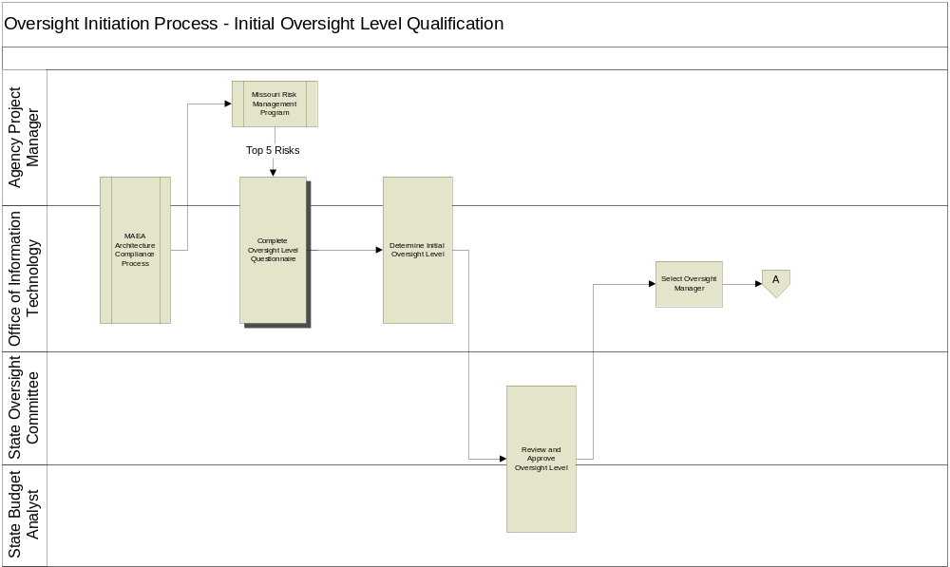

Initial Oversight Level Qualification

This sub-process is triggered by:

- Initiation of project oversight for a project.
- Completion of the MAEA Architecture Compliance Process and risk assessment using the Missouri Risk Management Program

MAEA Architecture Compliance Process – OIT in coordination with the agency project manager will perform the architecture compliance process for the project. The outcome of this process will provide architectural risks areas that are based on how well the proposed project architecture complies with the MAEA standards. This will provide information needed for the project’s risk assessment.

Missouri Risk Management Program – OIT and the agency project manager will implement the processes outlined in the Missouri Risk Management program to provide an initial project risk assessment. A key output from the Risk Management Program is a list of the top 5 risks for the project. This risk information becomes a critical input into the determination of the initial oversight level for the project.

Complete Oversight Level Questionnaire – The primary focus of the Project Oversight Program is the state’s most significant projects. These projects are designated as significant due to a number of factors including project characteristics, risks, issues, and constraints. These factors may include high costs, high business criticality, legislative mandates, administration policy importance, revenue generation, high public profile, and so on. This information is collected through the use of the Oversight Level Questionnaire.

Determine Initial Oversight Level – Recognizing that every state agency is unique, the Missouri Project Oversight Program (MPOP) will not attempt to deploy a ‘canned’ approach that meets the needs of every agency or every project. Virtually all projects require some level of oversight. Some may require project oversight or review administered by a formal structure; others may be more informal. Some may require validation by an independent third party; others may only require validation by internal agency personnel. The identification of an appropriate level of project oversight is critical to ensuring that proper processes and tools are applied to the oversight methodology.

The oversight level is used to determine the following aspects of project oversight:

- The oversight management and reporting structure
- The oversight information demands
- Frequency of oversight status reviews

The Office of Information Technology in conjunction with agency management determines the level of oversight that is appropriate for the project. This sub-process step utilizes an Oversight Level Matrix provide a somewhat objective means of determining the oversight level for the project. Using the internal and external risk assessment information from the Oversight Level Questionnaire, this matrix provides a somewhat objective means of determining the oversight level.

Oversight Level Matrix
EXTERNAL RISK | High | 2 | 3 | 3
EXTERNAL RISK | Med | 1 | 2 | 3
EXTERNAL RISK | Low | 0 | 1 | 2
 |  | Low | Med | High
 |  | INTERNAL RISK

Based on the level of internal and external risk, the table provides a value that identifies the project’s oversight level. This level is then used to determine the appropriate oversight information demands, oversight management and reporting structure, and oversight status review frequency. These are described in the Oversight Planning Process, Develop Oversight Plan sub-process.

It is important to note that this in only an initial oversight level. Once the Oversight Manager (if applicable) is brought onto the project, a final oversight level will be determined with the help of the oversight managers experience on past projects. Furthermore, the oversight level can continue to change based on potential changing project conditions.

Review and Approve Oversight Level – Members of the state oversight committee will review the project information, risks, and oversight level questionnaire results that led to the designated initial oversight level. A state budget analyst from the State Budget Office will be invited to participate in this review. The results of the review will be a final approval of the oversight level for the project.

Select Oversight Manager – Once the oversight level is ascertained, it will determine the necessity of an oversight manager. Level 1, 2, and 3 projects possess risk levels that necessitate the services of an oversight manager while level 0 projects do not. OIT and the agency project manager will determine the necessity for an oversight manager. OIT will be responsible for choosing the oversight manager and all contractual negotiations when contracting the oversight duties to a vendor. Once involved in the project, the oversight manager will reassess the oversight level with the assistance of the agency project manager, and OIT.

Due to the special needs of IT projects, it is recommended that the oversight manager possess considerable experience in the IT industry. A mix of both technical and project management experience is ideal. This will help ensure the oversight manager’s ability to effectively apply the oversight methodology.

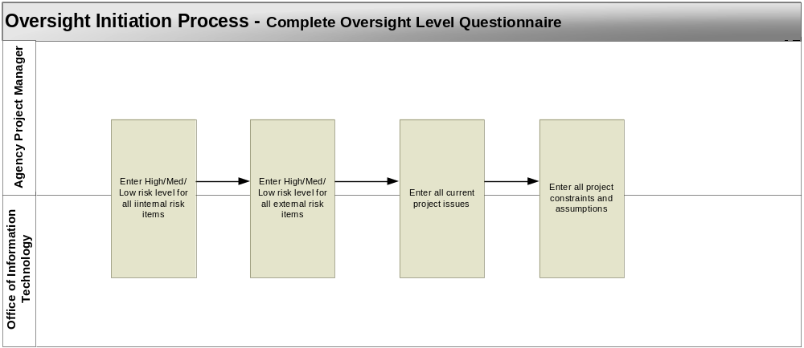

Complete Oversight Level Questionnaire

In order to initiate the oversight process and determine the need for an oversight manager, and assessment of project risks, issues, constraints, and assumptions should be performed Using the Oversight Level Questionnaire as a guide will help ensure a comprehensive assessment. The following process steps must be followed to aid in this effort:

Enter High/Med/Low Risk Level for All Internal Risk Items – The agency project manager and OIT representative (Normally the Oversight Controller) review the internal risk questions and provide a rating of high, medium, or low for the risk item.

Enter High/Med/Low Risk Level for All External Risk Items – The agency project manager and OIT representative (Normally the Oversight Controller) review the external risk questions and provide a rating of high, medium, or low for the risk item.

Enter All Current Project Issues – After entering the risk ratings for the internal and external risk sections, determine if there are outstanding issues that are not addressed by the risk questions. These issues might influence the level of oversight. It is important to remember that issues do not need to be negative in nature. For instance, a project may provide a benefit that is extremely valuable to the state and/or citizens. The value and perceived importance of this benefit might be a strong positive influence on the oversight level.

Enter All Project Constraints and Assumptions – Enter constraints and assumptions that are associated with the project. This information might be available from the Project Information Template.

MPOP Oversight Level Questionnaire

Questionnaire Overview

The Oversight Level Questionnaire provides a listing of project related questions for internal risk, external risk, project issues, constraints, and assumptions. All of the information gathered through the use of the questionnaire will be used to determine the initial oversight level for the project.

Template Sections

The Oversight Level Questionnaire will include the following sections:

- Internal Risk
- External Risk
- Issues
- Constraints & Assumptions

Oversight Level Questionnaire

The Oversight Level Questionnaire provides a vehicle for listing project information related to the determination of the oversight level in an electronic format. The visual representation of the Oversight Level Questionnaire is provided here. OIT and the agency project manager may access MPOP Oversight Level Questionnaire.dot for electronic entry of the project information.
Oversight Level Questionnaire
The Oversight Level Questionnaire will “do the math” for Risk Criteria calculations providing values that are plotted on the Oversight Level Matrix. The scoring process described below will assist in explaining how that initial oversight level is determined.

1. External Risk Level Criteria
Please answer the following questions and mark the box most appropriate for your project. In calculating scores, if necessary, round off to two decimal points.

1 point = low risk
2 points = medium risk
3 points = high risk

Impact on Citizens
How much of an impact will this project have on the average Missouri Citizen?
Significant impact - direct contact with citizen, including benefits to, payment by, and transactions with individuals (3 points)
Indirect impact – activity management systems that support decisions that are viewed as important by the public (2 points)
Insignificant or no impact – agency operations only (1 point)

Total score for Impact on Citizens

Visibility
How much visibility could this project potentially generate?
Highly visible – national or state recognition to the public and legislature (3 points)
Moderate visibility to the legislature with some of the systems or the program(s) it supports likely to be subject to hearings (2 points)
Insignificant or no visibility – internal to agency only (1 point)

What is the total estimated cost of the project?
$5 million or more (3 points)
$250 thousand to $5 million (2 points)
Less than $250 thousand (1 point)

How many agencies are involved in the project?
More than two agencies (3 points)
Two agencies (2 points)
One agency (1 point)

Total points for Visibility divided by 3 = total score Visibility

Impact on State Operations
What is the estimated impact on state operations?
Statewide or multiple agency impact (3 points)
Agency-wide impact (2 points)
Work group impact (1 point)

Total score for Impact on State Operations

Consequence of Doing Nothing
What are the consequences of not doing the project?
Inability to meet legislative mandate or agency mission (3 points)
Potential failure of aging systems (2 points)
Loss of opportunity for improved service delivery or efficiency (1 point)

Total score for Consequence of Doing Nothing

External Risk Exposure = (impact on citizens + visibility + impact on state operations + consequence of doing nothing) / 4

Total points for all external risk categories

= External Risk Exposure (Divide total points/4. Plot this score on the project assessment matrix)

- Internal Risk Level Criteria
The internal risk criteria provide a mechanism to help gauge the impact of the project on the organization, the level of effort needed to complete the project, the stability of the proposed technology and agency preparedness.
Organizational Impact
How much of an impact will this project have on the business rules of the organization?
Significant change to business rules (3 points)
Moderate changes to business rules (2 points)
Insignificant or no change to business rules (1 point)

What is the complexity of the business processes?

High complexity (3 points)
Medium complexity (2 points)
Low complexity (1 point)

How many organizations are involved?
Three or more organizations (3 points)
Two organizations (2 points)
One organization (1 point)

Total points for Organizational Impact divided by 3 = total score Organization Impact

Development Effort
What is the estimated development effort for the project?
More than 30 staff years (full time equivalent (FTE) & contractors) and/or more than 4000 function points (3 points)
10 to 29 staff years (FTE and contractors) (2 points)
Under 10 staff years (FTE and contractors) (1 point)

What is the duration of the project?
Over 3 years (3 points)
1 to 3 years (2 points)
Less than 1 year (1 point)

What are the estimated development/system integration costs?
$5 million or more (3 points)
$250 thousand to $5 million (2 points)
Less than $250 thousand (1 point)

Total points for Development Effort divided by 3 = total score Development Effort

Technology
What is the maturity of the technology being used?
Emerging, unproven and new for the state (3 points)
Proven in industry or at state level, but new for the agency or program areas
(2 points)
Standard, proven agency technology (1 point)

Total score for Technology

Capability
What is the capability level of the organization?
Immature organization, uses ad-hoc processes. Track record suggests inability to mitigate risk on project requiring a given level of development effort (3 points)
Maturing organization with a track record indicating a reasonable level of success but without the structure for repeatability (2 points)
Mature organization with a track record indicating a strong ability to mitigate risk to a project requiring a given level of development effort. Stable organization with a documented and repeatable process for tracking status, problems and change (1 point)

Total score for Capability

Internal Risk Exposure = (organizational impact + development effort + technology + capability) / 4

Total points for all internal risk categories

= External Risk Exposure (Divide total points/4. Plot this score on the project assessment matrix)

- Project Issues
List all current project issues, both negative and positive, that may have an influence on the oversight level determination. Be sure to key on issues that were not covered by the above internal and external risk items.
- Project Constraints and Assumptions
List all current project constraints and assumptions that may have an influence on the oversight level determination.
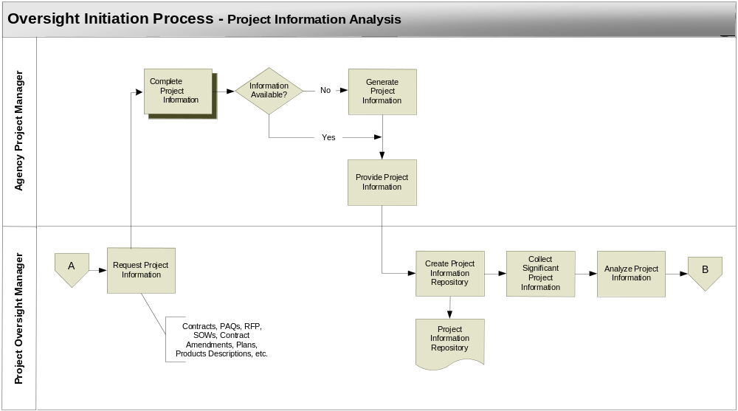

Project Information Analysis

This sub-process is triggered by:

- Completion of the Initial Oversight Level Qualification sub-process

Request Project Information – The oversight manager makes a request for project information from the agency project manager. This information will be available in various forms of documentation. At this time he makes the Project Information Template available.

Complete Project Information Template – The agency project manager collects the information using the Project Information Template as a guide.

Generate Information - If the information needed is not available in any existing project documentation, then it is an indicator that it should be generated. If it is determined that the information is important to the project given environmental factors and circumstances surrounding the project, then the agency project manager should generate it.

Provide Project Information – Once collected or generated, the information is made available to the oversight manager.

Create Project Information Repository – As documentation containing project information is received from the agency project manager, the oversight manager should organize it by developing an information repository. Both a physical and electronic environment should be made available, since it is likely that some documentation will not be available in electronic form.

Collect Significant Project Information – The oversight manager should start the project information search with the most significant documents. These will include the contractually binding documents listed in section I of the Project Information Template and any additional documents that have been deemed significant by the oversight manager and agency project manager. The documents are searched for information that is significant to the project.

Analyze Project Information – The information collected is then analyzed with two main objectives in mind. First, gain a general understanding of the project, the product/service to be produced, and the project environment. The second is to drive out high risk areas for the project that will require additional attention throughout the application of project oversight.
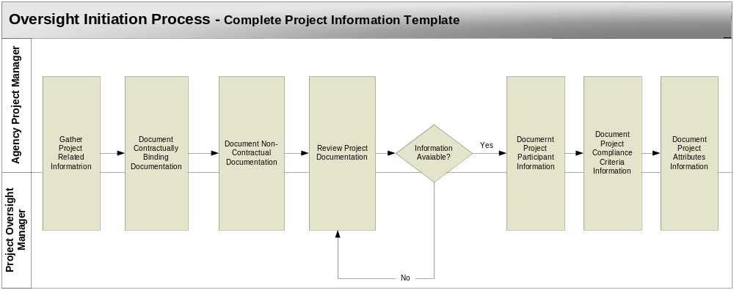

Complete Project Information Template

After receiving the request for project information from the oversight manager, the agency project manager must provide the information. Using the Project Information Template as a guide will help ensure a complete set of documentation and project information. The following process steps must be followed to aid in this documentation:

Gather Project Related Information – Search current documentation repositories to locate and gather documentation that is related to the target project. The Project Information Template lists the typical types of documentation associated with government IT projects. Any additional documents that do not fit into these ‘types’ should also be collected. Electronic copies of documentation are preferred.

Document Contractually Binding Documentation – This step assumes that there is a contractor involved in the project with a contractual obligation to the state agency to deliver project related products and/or services. All contractually binding deliverables will be found in these documents.

Separate the contractually binding from the non-contractual documents. (Contractual document will be important to determining the deliverables list during the Oversight Planning Process). The contractually binding documents are automatically considered significant documents. Enter the name and location of the contractually binding documents.

Document Non-contractual Documentation – Enter the name and location of all non-contractual documents. Although these documents are not contractually binding, they still can provide insight into the project and help identify project needs and risks. In the case of a project with no contracted labor, this documentation will be the sole source of information for the project.

Review Project Documentation – The project information identified in the template is needed by the oversight manager and the agency project manager. Review this list and search the documents listed above to determine where this information can be found if it is available.

Document Project Participant Information – If the information is found, enter the document name, section number or heading, and page number. This will provide an index into the documents that will be used during later analysis efforts.

Document Project Compliance Criteria Information - If the information is found, enter the document name, section number or heading, and page number. This will provide an index into the documents that will be used during later analysis efforts.

Document Project Attributes Information - If the information is found, enter the document name, section number or heading, and page number. This will provide an index into the documents that will be used during later analysis efforts.
Project Information Template

Template Overview

When requesting project documentation, the oversight manager needs to receive a complete set of documentation. This template will serve as a checklist to help the agency project manager to provide what is needed. The completed template will provide a comprehensive listing of initial project documentation and the location where it can be found (preferably electronic). This will aid the oversight manager in his research and analysis of project information.

Completing this template is the responsibility of the agency project manager. However, it may help to move the process forward and more complete information may be gathered if the oversight manager assists.

Template Sections

The Oversight Project Information Template will include the following sections:

- Contractually Binding Documentation
- Non-Contractual Documentation
- Project Information

Template Form Sample

The Project Information Template provides a vehicle for listing the project documentation in an electronic format. The visual representation of the Project Information Template, provided here, is followed by the detailed description of its contents. The oversight manager and agency project manager may access MPOP Oversight Project Information Template.dot for electronic entry of the project information.
Project Information Template
contractually binding documentation
Type |  | Name |  | Location
Contracts
Contract Amendments
PAQs
RFPs
Contractor Proposals
Statement of Work
State Requirements
Federal Requirements
Other
Non-Contractual Documentation
Type |  | Name |  | Location
Implementation Plan
Risk Assessments
Preliminary Schedules
System Descriptions
COTS Product Specs
Other
Project Information
 | Document Name |  | Section Number or Heading |  | Page Number
Project Participants
Stakeholders
Organizations
Vendors & Contractors
Project Team
Agency Project Manager
Oversight Committee
Roles & Responsibilities
Compliance Criteria
Laws
Policies
Procedures
Methods
Standards
Mandated Technology
Project Attributes
Products/Services
Deliverables
Deadlines
System Functions
Size
Complexity
Initial Issues
Constraints
Assumptions
Risks

Template Detail

Section I – Contractually Binding Documentation

Type – Indicates the type of documentation required.

Name – Provide the name of the document.

Location – Provide the location of the document. It is preferred that all documentation be made available in electronic form. If the document is in electronic form provide the system environment, a directory structure and a file name where the document can be accessed. If the document is only available in hardcopy, provide a building, room number and document owner.

Section II – Non-Contractual Documentation

Type – Indicates the type of documentation required.

Name – Provide the name of the document.

Location – Provide the location of the document. It is preferred that all documentation be made available in electronic form. If the document is in electronic form provide the system environment, a directory structure and a file name where the document can be accessed. If the document is only available in hardcopy, provide a building, room number and document owner.

Section III – Project Information

Type – Indicates the type of information required

Location – List the document found in sections I and II where this type of information can be found. This should include the document name, section number or heading, and page number.

