Chapter 2: Oversight Planning Process
This chapter provides a description of all processes, templates and report examples that are part of the Oversight Planning Process. This process is a precursor to the Oversight Implementation Process.

Overview

Before moving forward with project oversight execution, some key planning activities will ensure that the oversight methodology is properly tailored to fit the needs of the project and that the oversight tools are selected, prepared and ready for use. This critical element of the project oversight methodology is comprised of the following sub-processes:

- Develop Oversight Plan
- Complete Oversight Strategy Template
- Complete Project Oversight Plan Document
- Build Oversight Project Model
- Communicate Project Oversight

Sub-Processes & Templates

Each sub-process follows the same format:

Process Model
Process Detail
Template (if applicable)
Overview
Sections
Sample Template Form
Template Detail

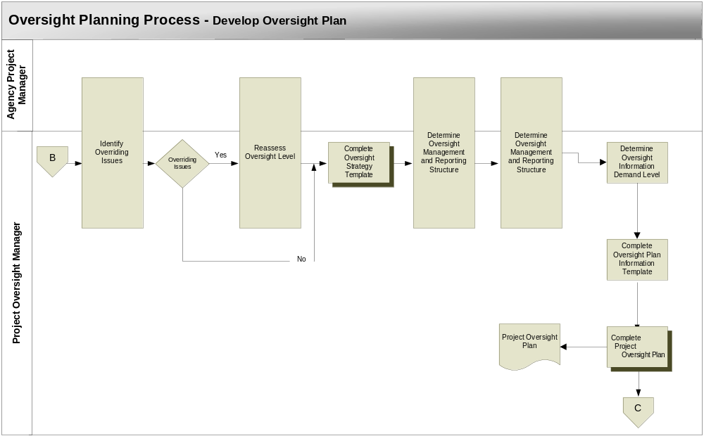

Develop Oversight Plan

This sub-process is triggered by:

- Completion of the Oversight Initiation Process
- A strong understanding of project risks

Identify Overriding Issues – The initial oversight level identified in the Oversight Initiation Process is determined using a relatively objective process. While this provides a reasonable assessment of the project risks, it may not produce an appropriate oversight level. There may be one or two overriding issues that are exceptionally concerning to the project stakeholders. These must be identified and assessed in order to determine the final oversight level. Examples of these overriding issues might be:

- High political visibility
- Contractor/no contractor participation
- Federate mandates
- Unfamiliar technology
- Extremely high cost
- Extremely valuable benefit

Reassess Oversight Level – This step is not included in the Oversight Initiation Process because the oversight manager is not yet involved in the project during this early stage of the oversight methodology. It is important to include the oversight manager in the determination of the final oversight level because of the opportunity to draw upon the oversight manager’s oversight experience. It is also important for the oversight manager to have buy-in into the oversight level and it’s implications for the oversight effort.

Overriding issues are identified by reviewing all internal and external risk items with a rating of 3 (high) in the Oversight Level Questionnaire. Using the following criteria, these are assessed to determine if they should receive special consideration as overriding risk items:

- Will this item create a need for change in project documentation formality and level of detail?
- Will this item create a change in the need for communication to project stakeholders?
- Will this item create a change in the oversight status review frequency?

If overriding issues have been identified there may be a need to reassess the oversight level to ensure it’s appropriateness to the project. After review of overriding issues, the oversight manager and agency project manager may find it necessary to either increase or decrease the initial oversight level. Because this step involves a high level of subjectivity, there is no scientific or mathematical method of overriding the oversight level with a new one. The oversight manager and agency project manager must draw from experience and the circumstances surrounding the project to assess the effect of overriding issues on the project.

Complete Oversight Strategy Template – Using the Oversight Strategy Template as a guide collect all information that is important to developing the oversight strategy for the project. The oversight manager develops a strategy for performing oversight on the project. The strategy is determined through an assessment of risk and it identifies key project artifacts that will receive additional oversight attention in response to the risk. It also helps to determine the final set of project oversight artifacts/deliverables that will be tracked during the oversight effort using the OPM.

Determine Oversight Management and Reporting Structure –
The level of oversight will determine the management and reporting structure that is necessary for the project. The following matrix is used to determine the oversight management roles that are necessary given a specific oversight level.

OVERSIGHT LEVEL | OVERSIGHT MANAGEMENT STRUCTURE
OVERSIGHT LEVEL | Agency Project Manager | Oversight Controller | Oversight Manager | Oversight Reviewer | Oversight Committee
0 | √ | √
1 | √ | √ | √ | √
2 | √ | √ | √ | √
3 | √ | √ | √ |  | √

Oversight Management Structure Matrix

The application of the oversight methodology and the reporting of status will generally be based on the following:

Oversight Level 0 – Because of the low level of risk, there is no expectation for an outside oversight manager or oversight committee. The agency project manager determines whether to implement oversight on the project and then becomes responsible for it. In affect, oversight will be “self-applied”, meaning the project manager will oversee his/her own project. The project manager can obtain the oversight methodology and tools from the oversight controller. While the agency project manager report status based on the internal agency IT status report process, there is no reporting of oversight status.

Oversight Level 1 – The oversight controller makes the determination that an outside project oversight manager is required. The oversight manager works with the agency project manager to implement the oversight processes. There is no expectation for an oversight reviewer or oversight committee. Oversight status is only reported to the oversight controller.

Oversight Level 2 - The oversight controller makes the determination that an outside project oversight manager is required. The oversight manager works with the agency project manager to implement the oversight processes. Because there are only two organizations involved in the project, there is no expectation for an oversight committee. Instead, oversight status will be provided to an oversight reviewer who will be the key stakeholder of the project (typically a member of agency executive management) Oversight status is also reported to the oversight controller to allow for monitoring higher risk projects across the state.

Oversight Level 3 - The oversight controller makes the determination that an outside project oversight manager is required. The oversight manager works with the agency project manager to implement the oversight processes. Because there are three or more organizations involved in the project, it is very important that an oversight committee (comprised of all project stakeholder representatives) be involved. Oversight status will be provided to the committee by the oversight manager during monthly oversight committee meetings. Oversight status is also reported to the oversight controller to allow for monitoring higher risk projects across the state.

Determine Oversight Information Demands- The oversight demand for information simply provides expectations of the quality and characteristics of information that will be produced as part of developing the project artifacts/deliverables. This will serve as a guide to the oversight manager during the evaluation of project deliverable quality, performed as part of the Oversight Implementation Process. Using the oversight level identified in the Oversight Level Qualification Process, the oversight manager will determine the associated oversight information demands using the following matrix:

OVERSIGHT INFORMATION DEMAND
GENERAL CHARACTERISTICS
 |  |  |  | Organization  Information |  | Product/Service Information
Oversight Level | Description | Activity | Structure | Content | Priority | Content | Priority
0 | Minimal risk with few people, generally would support informality. | Low | Informal | Brief | Low | Detail | High
1 | Minimal risk with few people, generally would support informality. | Low | Informal | Brief | Low | Detail | High
2 | More risk, more people, generally needs more formality, information is brief yet thorough. | Low-Med | Formal | Brief-Detail | Med-High | Detail | High
3 | Definite risk with many people, demands structure and detail to communicate effectively at all levels. | Med-High | Formal | Detail | High | Detail | High

Oversight Information Demand Matrix

The information in this table provides expectations of the activity, content, structure and priority of the artifacts/deliverables that will be used to populate the OPM. A definition of each of these information demand characteristics is found in the following table:

Information Demand Characteristics Definitions
Characteristic | Description | Values
Activity | The reference to "activity" is with respect to project and product information being passed within and between project groups. It is also the degree that information, such as requirements, will change. This activity can also be thought of as "information churn". A smaller project is the information may not be as varied and interdependent, therefore the level of activity may be generally thought of as low. Much of the information sharing occurs at an implicit level. In a larger project, the interdependency for project groups sharing information is high. Therefore there will be a rise in explicit information and more overt sharing of information. | High  Med  Low
Structure | Regardless of project size, it is always necessary to handle information distribution, modifications, additions, and deletions. However as projects grow so do the demands to sharing information. This, in turn, increases the need for a more structured, formal means of developing the information and making it available. For large projects, the synchronization of versions of information becomes more important. This means methods techniques and tools have to be in place to control and manage the synchronization. A key underlying need is always to maintain and find the right information in an efficient way. | Informal  Formal
Content | The amount of content in an explanation can vary with the size of the project. More detail is needed for a larger project because of the need to be more explicit. This helps the reader understand the information. In a large project, the expectation to go and ask the writer what they mean may not be an option. Also there is the real concern with providing proper documentation. This is particularly true when taking into consideration the legal necessity to be thorough. A large internal project may be able to avoid being so meticulous but with contractors and vendors, information must be explicit. | Brief  Detail
Priority | Priority is established based on level of necessity to have this information available. The oversight baseline model provides a list of all possible artifacts/deliverables for an IT project. While all of the information provided by these is important, it is important in varying degrees. For instance, information that describes the delivered product is critical, while project organization information is not as important. | High  Med  Low

Information Demand Characteristics Definitions

Determine Oversight Status Review Frequency – The oversight status review is defined as a meeting of project stakeholders with the oversight manager and agency project manager with the expressed purpose of communicating project issues that have been identified through the oversight processes. It has been determined that most projects, regardless of oversight level, will require a monthly review of oversight status. Less frequent reviews may lead to a delay in addressing critical project issues. More frequent reviews may be impractical due to difficulties associated with bringing all project stakeholders together more often than once a month.

While most project will require monthly oversight status reviews, there may still be situations where more or less frequent meetings are necessary. This will depend upon the following factors:

- Frequency of Major Milestones – A project involving frequent delivery of major milestones may require more frequent reviews. This will be determined by a review of the overall project schedule.
- Project .Schedule Length – A project schedule that is very short may require more milestones in a shorter period of time. This increase in project deliveries may require a more intensive oversight effort and more frequent review of oversight status.
- Fast Approaching Project Deadline – As a project approaches critical deadlines, the frequency of oversight status reviews may increase. This is especially true when the deadline is immovable such as in the case of Y2K or a federally mandated deadline such as with HIPAA.

Complete Project Oversight Plan Document – The Project Oversight Plan is the key document produced in the oversight methodology. It provides guidance for the entire oversight effort for the project. An example of this document is found at MPOP Oversight Plan Document Example.doc. This example provides a standard format, set of document section headings, and information that is common to all oversight plans regardless of the unique characteristics of a particular project. This will give each oversight plan a common look and feel as well as standardized organization. Instructions for completing the Oversight Plan Document is provided in the Complete Project Oversight Plan Document sub-process.

Note: Using the information collected in the Oversight Strategy Template the oversight strategy can be developed and included in the Oversight Plan Document.
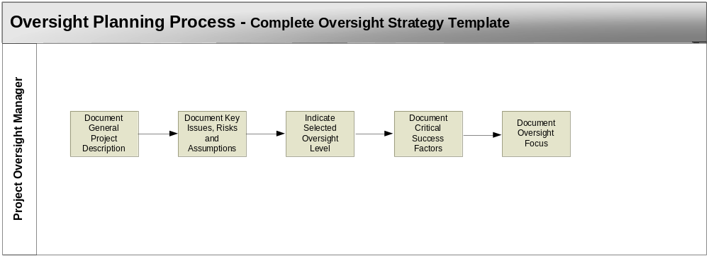

Complete Oversight Strategy Template

The developing the oversight strategy is essential to a successful oversight effort that is focused on the deliverables and processes that require additional attention. Using the Oversight Strategy Template as a guide will help ensure that all important elements of the oversight strategy are reviewed. The following process steps must be followed to aid in this documentation:

Document General Project Description – Input a one or two paragraph description of the project. This should include why the project exists, the needs addressed by the project, a high level description of the functions and features of the products produced and any state laws or directives that have created the need for the project.

Document Key Issues, Risks, and Assumptions – Input the issues, risks and assumptions that are identified as the most important. These will tend to drive the project and must be given special attention throughout. The oversight strategy should focus on these areas. This information is collected in the Oversight Level Questionnaire and can be borrowed from it.

Indicate Selected Oversight Level – Check off the oversight level that applies to this project. This was determined during the Oversight Initiation Process risk assessment and oversight level determination.

Document Critical Success Factors – Input a description of the critical success factors for the project. These can be determined through a careful assessment of the high level risk areas for the project. Risk mitigation strategies will often point to the critical success factors of a project.

Document Oversight Focus – Input a description of the project deliverables and processes that will require increased and more frequent oversight attention during the course of the project.

Oversight Strategy Template

Template Overview

This template is to be used as a guide to developing the oversight strategy. This strategy will provide direction to the oversight planning efforts. From the information gathered in this template the oversight strategy is written and included in the oversight plan.

Template Sections

The Oversight Strategy Template will include the following sections:

- General project description
- Key issues, risk and assumptions
- Selected oversight level
- Critical Success Factors
- Oversight focus

Template Form Sample

The Oversight Strategy Template provides a vehicle for documenting the oversight strategy details in an electronic format. The visual representation of the Oversight Strategy Template, provided here, is followed by the detailed description of its contents. The oversight manager may access MPOP Oversight Strategy Template.dot for electronic entry of the Oversight Strategy detail.

Oversight Strategy Template

Oversight Strategy Template
GENERAL PROJECT DESCRIPTION
Key Issues, Risks, and Assumptions
Issues
Risks
Assumptions
Selected Oversight Level
Level 0 |  |  |  | Level 3
Level 1 |  |  |  | Level 4
Critical Success Factors
Oversight Focus
Deliverables
Processes

Template Detail

Section I – General Project Description
A general description of the project.

Section II – Key Issues, Risks and Assumptions
Issues, risks and assumptions that will affect the oversight strategy and planning. This information will help identify where the focus of oversight should be.

Issues – Problems or concerns that are known at the outset of the project

Risks – Known aspects of the project or project environment that have the potential to cause schedule, budget overruns or other difficulties with the project

Assumptions – Information about the project or project environment that can affect decision making.

Section III – Selected Oversight Level
This is the oversight level selected during the TCO/ROI risk assessment process.

Section IV – Critical Success Factors
This section provides a description of the critical success factors for the project. This will help to identify the oversight focus of the following section.

Section V – Oversight Focus
This is a description of the main management focus regarding the oversight methodology. Based on the risks of the project certain deliverables and processes will receive additional focus to ensure their successful completion.

Deliverables – Documents or information produced through the course of the project

Processes - Management or product development activities designed to accomplish a project task.

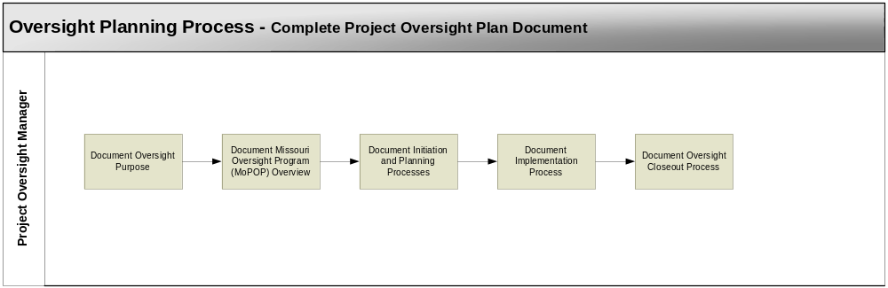

Complete Project Oversight Plan Document

Using the Oversight Plan Document Example as a guide will help ensure that all important elements of the oversight plan are included in the final Oversight Plan Document. The Oversight Plan Information Example can be found at MPOP Oversight Plan Document Example.dot. and can be used to develop the electronic version of the document. The following process steps must be followed to aid in this documentation:

Document Oversight Purpose – Develop a statement of the Oversight purpose for this project. The Oversight Plan Document Template provides a standard write-up for the oversight purpose that is suitable for most projects. However, the oversight manager may wish to add information specific to each particular project.

Document Missouri Oversight Program (MPOP) Overview – The Oversight Plan Document Example provides a standard write-up for the MPOP overview and will be sufficient for all projects.

Document Initiation and Planning Processes – Document project-specific information pertaining to the initiation and planning processes of the project. Included will be the following sub-sections:

- Oversight management roles and reporting structure
- Identification of Oversight Committee members (if applicable)
- Oversight communication channels
- Oversight Project Model description
- Project Critical Success Factors

Document Implementation Process – The Oversight Plan Document Example provides a standard write-up for the MPOP Implementation Process and will be sufficient for all projects. There should be few if any changes to this section. This includes descriptions of the following:

- Proactively Monitor Performance
- Evaluate Quality
- Update Project Model
- Provide Recommendations
- Project Manager Support
- Establish Communications Through Comprehensive Reporting

Indicate Selected Oversight Closeout Process – The Oversight Plan Document Example provides a standard write-up for the oversight closeout process that is suitable for most projects. However, the oversight manager may wish to add information specific to each particular project.
.
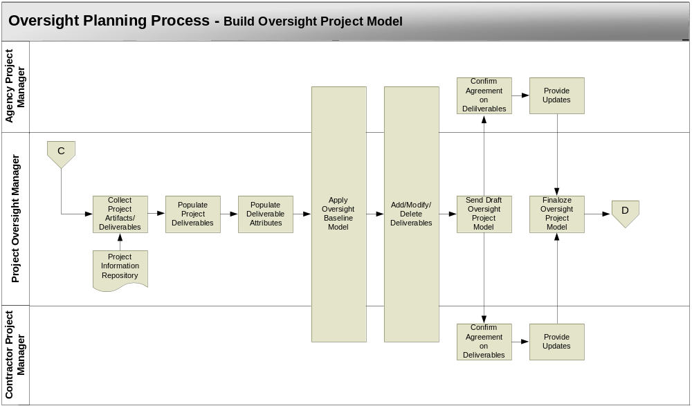

Build Oversight Project Model

This sub-process is triggered by:

- Completion of the Oversight Plan Document
- The need to begin the Oversight Implementation Process

Collect Project Artifacts/Deliverables – Using the documentation found within the Oversight Information Repository, search for and collect all project artifacts/deliverables. Generating this compilation of artifacts/deliveries involves the careful, page-by-page examination of these documents. This is started by identifying all nouns in the documents. Each noun is then assessed by the oversight manager as to its qualification as an actual project artifact or deliverable.

Populate Project Deliverables – While all project artifacts are important, the deliverables are the primary focus of 90% of the Oversight Implementation Process. As a result, the OPM is populated with project deliverables. The key objective of the OPM is to provide an organized view of the project. This step involves organizing the project deliverables into the OPM. An electronic example of an OPM is provided in a Microsoft Excel spreadsheet, MPOP Oversight Project Model Example.xls. The deliverables will be inserted into a spreadsheet using the same general format and organization as is found in this example.

Since projects are in existence to produce products/services, the products/services are identified and the project deliverables are categorized under them. Breakdown of products/services into product components further helps to organize deliverables into manageable pieces of the project. The following is a list of products/services categories into which most IT project deliverables will fall. Since each project is unique, each one may have more or fewer product/service category names:

- Project Management
- Infrastructure Development (Environments)
- Software Development
- Quality Assurance
- Data Conversion/Migration
- System Deployment
- Training
- Support Services

Each of these can be broken into product components. This decomposition will vary for each project. Some projects will require multiple product components, while others will require none because all deliverables fit neatly under a product/service category. For instance, Software Development product/service may be decomposed into Analysis, Design, Coding, and Test. This would be due to a large number of deliverables that are easily distinguished into product components. At the same time, the Training product/service may be very simple with very few deliverables. In this situation, no product component will be needed.

Populate Deliverable Attributes – Each deliverable is populated into the OPM with associated information that allows for the monitoring of project progress and quality. These pieces of information are referred to as deliverable attributes. These include:

- Dependencies
- Quality Points
- Status
- Responsible Party
- Deliverable Requirement

A description of dependencies, quality points, status and their use is provided in the Oversight Implementation Process.

The responsible party is simply the name of the person or organization that is responsible for delivery of the deliverable. If the deliverable requirement is contractually binding, then for contractual purposes it is very important that there be complete agreement on the responsible party attribute. Clear consensus should be reached by the agency project manager and contractor project manager at the outset of the project, because future disputes over deliverable responsibility can have very negative impacts on the project schedule.

The Deliverable Requirement attribute provides a reference to the document where the deliverable requirement was found during the Collect Project Artifact/Deliverable step. These two artifacts are typically static information that is very valuable as a quick reference.

Apply Oversight Baseline Model – At this point, the OPM must be verified by the oversight manager, agency project manager, and contractor project manager (if applicable). For the OPM to be an effective tool a consensus must be reached regarding the final list of deliverables and associated attributes. Otherwise, all parties will have varying expectations and usefulness of the OPM will be severely hampered

It is important to remember that the most important element of the oversight methodology is the creation, maintenance, and application of the OPM. As a means to develop the OPM and ensure its accurate reflection of the project, the methodology utilizes an oversight baseline model. This model is simply a predefined set of project deliverables and deliverable attributes that are typically produced as part of IT projects. The makeup of the model is based upon oversight experience on previous projects and project management best practices. The complete oversight baseline model is found in Appendix A.

The application of the model involves its use as a checklist. Once the OPM is fully populated with deliverables and deliverable artifacts, the model is used to determine if the set of deliverables is complete given the unique needs of the project. The oversight manager must walkthrough the baseline model and answer two questions for each deliverable:

  - Has the deliverable been populated in the OPM?
  - If not, should it become a deliverable in the OPM?

The oversight manager must be aware that the baseline model deliverable name and the OPM deliverable name may be different, but the purpose of the two differently named deliverables is the same. If the deliverable is already present in the OPM, then it can be “checked off” in the baseline model. If not found in the OPM, then the baseline model deliverable is “checked off” when determination has been made for question 2. Through this process it is expected that an OPM that is approximately 90% complete can be generated.

Add/Modify/Delete Deliverables – Depending on the nature of the project, there may be additional deliverables that have been omitted. These may be added and tagged as recommended deliverables. In addition, further review of all OPM information may reveal the need to delete a deliverable. With changes to the deliverables comes the potential need to modify the deliverable dependencies and quality points.
Send Draft Oversight Project Model – It is the responsibility of the oversight manager to send the draft OPM out to the agency project manager and contractor project manager for a final review.

Confirm Agreement on Deliverables – Both the agency project manager and contractor project manager must review the OPM and confirm agreement with the oversight manager on its accuracy. Through confirmation all parties are agreeing that the OPM is a valid tool for oversight.

Provide Updates – In the event of a disagreement on the OPM, the agency project manager and/or the contractor project manager must send recommended updates to the oversight manager.

Finalize Oversight Project Model – The oversight manager will review the recommended updates and make the OPM changes if all parties confirm agreement.

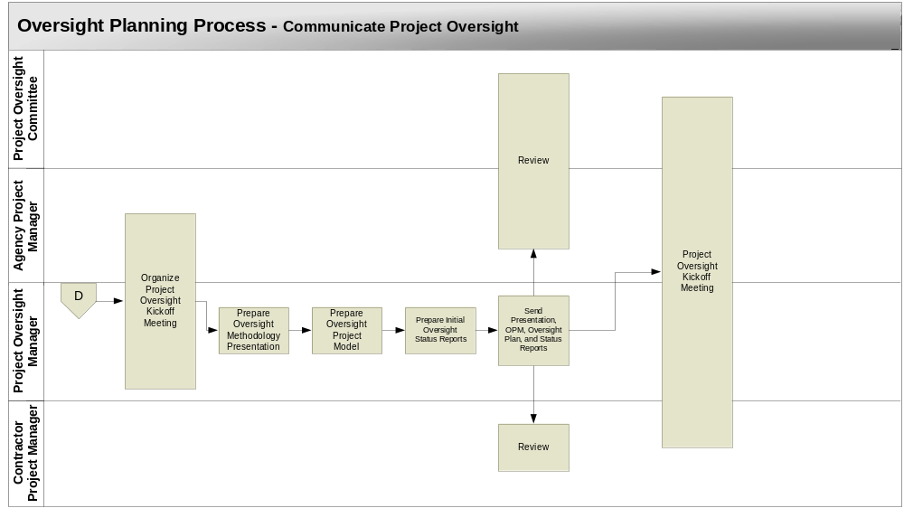

Communicate Project Oversight

This sub-process is triggered by:

- Completion of the Oversight Project Model and the Oversight Plan

Organize Project Oversight Kickoff Meeting – The oversight manager and the agency project manager will coordinate a date, time and facility for an oversight kickoff meeting. The purpose of this meeting is to communicate all elements of project oversight to the project stakeholders.

Prepare Oversight Methodology Presentation – This presentation should provide an overview of the concepts and processes involved in the oversight methodology. A template presentation has been prepared and is found in MPOP Oversight Methodology Presentation.ppt In preparing the presentation, the oversight manager may want to include project-specific information.

Prepare Oversight Project Model – The OPM should be ready for application. Any final changes should be completed.

Prepare Initial Oversight Status Reports – The initial Oversight Summary Status Report and Oversight Issues Report should be created and ready for presentation.

Send Presentation, OPM, Oversight Plan, and Status Reports- All presentations and oversight tools should be sent to all meeting attendees for their review before the kickoff meeting. It is best if this is sent at least 48 hours prior to the meeting.

Review – The oversight kickoff meeting attendees should review the presentation information in preparation for the meeting. This will allow them to prepare questions for the oversight manager. This will enhance communication of oversight.

Project Oversight Kickoff Meeting – It is very important that the project stakeholders understand the oversight methodology and its purpose. In addition they should be aware of how oversight will benefit the project. The kickoff meeting will require about 2 hours to present the oversight methodology and concepts, the Oversight Project Model, and the status reports and reporting process.

