Chapter 3: Oversight Implementation Process
This chapter provides a description of all processes, templates and report examples that are part of the Oversight Implementation Process. This process is a precursor to the Oversight Closeout Process.

Overview

While the Initiation and Planning processes are aimed at preparing for oversight activities, the Oversight Implementation Process encompasses all activities necessary to apply the oversight methodology to the project. Much of the implementation process involves the use of the Oversight Project Model (OPM) and the various status tracking and reporting tools. The process is comprised of the following sub-processes.

- Monitor Deliverable Dependencies
- Evaluate Deliverable Quality
- Report Oversight Status
- Complete Oversight Summary Report
- Complete Project Improvement Plan Template
- Complete Oversight Issues Report
- Complete Oversight State Projects Rollup Report
- Monitor Issues/Actions

Sub-Processes & Templates

Each sub-process follows the same format:

Process Model
Process Detail
Template (if applicable) - There are no templates as of this draft.
Overview
Sections
Sample Template Form
Template Detail
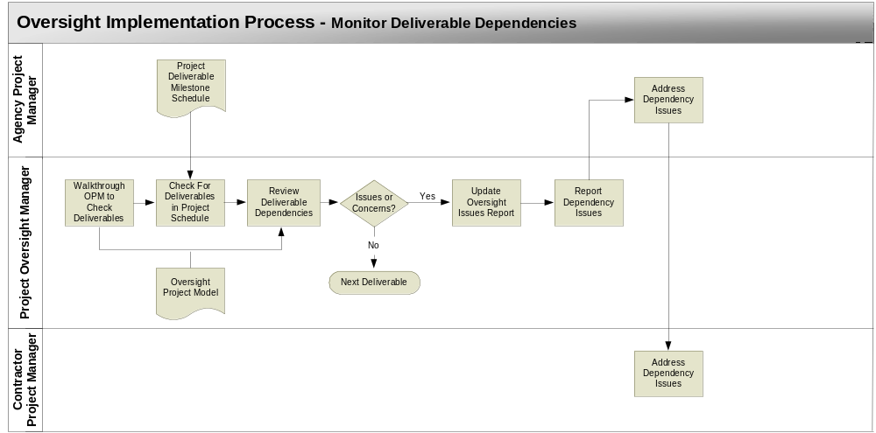

Monitor Deliverable Dependencies

This sub-process is triggered by:

- A regular cycle of reviewing project deliverables

A simplistic view of project oversight includes project monitoring and reporting of status based on the current situation. This provides a view into past performance that has led to the current “snapshot” of project status. It is possible to identify problems and issues, report them, and provide recommendations targeted at their remediation. The problem with this approach is there is no mechanism with the purpose of foreseeing and avoiding the problems and issues in the first place. An ounce of prevention is worth a pound of cure.

The Missouri Oversight Methodology includes this simple monitoring and reporting function, but it also takes a more proactive approach through the use of forward-looking reviews. This is made possible by identifying dependencies for each deliverable. Dependencies are simply activities or deliverables that the future deliverable is dependent upon. Dependencies allow for the oversight manager to look ahead in the schedule, identify deliverables that are due in the distant future, and point the project manager in the direction of key activities that must be accomplished in the near future to support that delivery.

The argument can be made that this is really a project management task. This is true, however project managers often become embroiled in the details of immediate issues. When this occurs, other lower priority tasks can be lost in the chaos. It is the job of the oversight manager to keep the project manager focused on the big picture view of the project and help prevent these tasks from being overlooked. If not tended to in the present, some of them can create larger project delays later in the schedule.

On a regular basis, the oversight manager must review the schedule to identify upcoming deliverables. A careful examination of each deliverable’s dependencies listed in the OPM will point to tasks or deliverables that require near term attention

Walkthrough OPM to Check Deliverables – The oversight manager will walkthrough the OPM and identify each deliverable.

Check For Deliverables In Project Schedule – For each deliverable in the OPM, search the project schedule for the same deliverable.

Review Deliverable Dependencies – Review the deliverable dependencies to identify activities or deliverables that the target deliverable is dependent upon. A determination must be made as to whether the dependency is on schedule or not. Search the project schedule to find the dependency in the task list. Determine whether it has been started on time and/or is progressing toward a timely completion. If the dependency is not included in the project schedule this may indicate an oversight in project planning.

Update Oversight Issues Report – If there are concerns regarding the scheduled completion of the dependency or if the dependency is not present in the schedule, then on-time delivery of the deliverable may be in jeopardy. If the deliverable is part of the critical path for the overall project, then the implications of the late dependency delivery may be very significant.

The oversight issues report that is generated each month (See Report Oversight Status Sub-Process) should be updated to include any new dependency issues discovered during this dependency review.

Report Dependency Issues – Using the oversight issues report, the new dependency issues are immediately reported to the agency project manager. This ensures that the issues will receive attention in a timely manner and help avoid future project delays.

Address Dependency Issues - The agency project manager must determine how to address the issues and assign ownership to them. If the contractor is responsible for the dependency in question, then the issue is handed over to the contractor project manager. The oversight issues report will be used in the future to track the dependency issues and obtain status updates on their resolution.

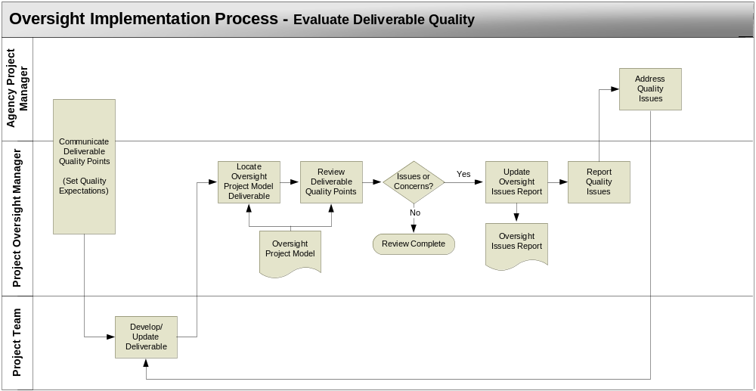

Evaluate Deliverable Quality

Quality is typically defined by the content, accuracy, and completeness of project deliverables. With the exception of the major schedule milestones and budget, project oversight for Missouri is not intended to delve into the lower level details of a project. Therefore, quality from an oversight perspective is defined only by content and completeness. The oversight manager is not expected to obtain a level of knowledge that allows for an evaluation of accuracy. This is left for the project managers and technical team.

Note: This program has been developed to address the oversight processes expected for a majority of IT projects. However, there may be projects that are atypical and may require Independent Verification & Validation (IV&V) activities that are performed by the oversight manager. If the IV&V activities are highly technical in nature, it may require the services of additional technical personnel that work with and are directed by the oversight manager.

The evaluation of quality is accomplished using the OPM and the project deliverables that have been collected. The quality factors identified and included for each deliverable are used to assess whether the essential elements of the deliverable have been considered and/or included. They also help to evaluate the quality of the project processes involved in producing the deliverable. The oversight manager uses the list of quality factors as a checklist. Reviewing the quality factors naturally spawns questions in relation to the quality of an artifact. For example, the quality factors related to a software test plan include a minimum of:

- Test team appointments
- Test schedule
- Test environment description
- Test cases
- Test scripts

Using the test environment description as an example, to produce this element of a test plan, the technical team must identify testing location, facilities, equipment, operating system, software product version number, etc, all of which are critical to running a test. If the test plan does not include a test environment description then the quality of the test planning and coordination effort is suspect. Likewise, if test scripts are not included, then test consistency and repeatability is not possible, thus reducing the test quality. Similar assessments of quality are possible for all aspects of a project through the inspection of the artifact quality factors.

There are two aspects to this sub-process that are triggered in two different ways:

- It is important that the quality points get communicated to the deliverable responsible parties in order to set expectations. This is triggered by the start date designated in the project schedule for the deliverable. This triggers the “Communicate Deliverable Quality Points” step.
- The completion of a deliverable is the trigger for reviewing the deliverable quality which starts with the “Develop/Update Deliverable” step.

Communicate Deliverable Quality Points – To ensure that expectations for deliverable quality points are understood, the oversight manager must communicate them to the project team. The project contract should include deliverable expectations and this should be reviewed. This will help ensure that the deliverable will be produced according to the needs of the project and both the oversight manager’s and agency project manager’s expectations.

Develop/Update Deliverables – The project team (either agency or contractor staff) will produce or update the deliverable as per the project plan.

Review Deliverable Quality Points – This step involves a review of the deliverable and inspection using the predefined quality points. The oversight manager locates the deliverable in the OPM. The listed quality points are used as a checklist to ensure that all important aspects of the deliverable have been addressed.

Update Oversight Issues Report – If there are concerns regarding deliverable quality, it may lead to more critical issues related to the actual process, product, or service being addressed in the deliverable. The oversight issues report (See Report Oversight Status Sub-Process) should be updated to include any new quality issues discovered during this quality review.

Report Quality Issues - Using the oversight issues report, the new quality issues are immediately reported to the agency project manager. This ensures that the issues will receive attention in a timely manner and help avoid future project delays.

Address Quality Issues - The agency project manager must determine how to address the issues and assign ownership to them. If the contractor is responsible for the quality issue, then the it is handed over to the contractor project manager. The oversight issues report will be used in the future to track the quality issues and obtain status updates on their resolution.

Resolution of quality issues will result in an update to the deliverable. Once the update is complete it must go back through this review cycle to ensure the quality points have been addressed.
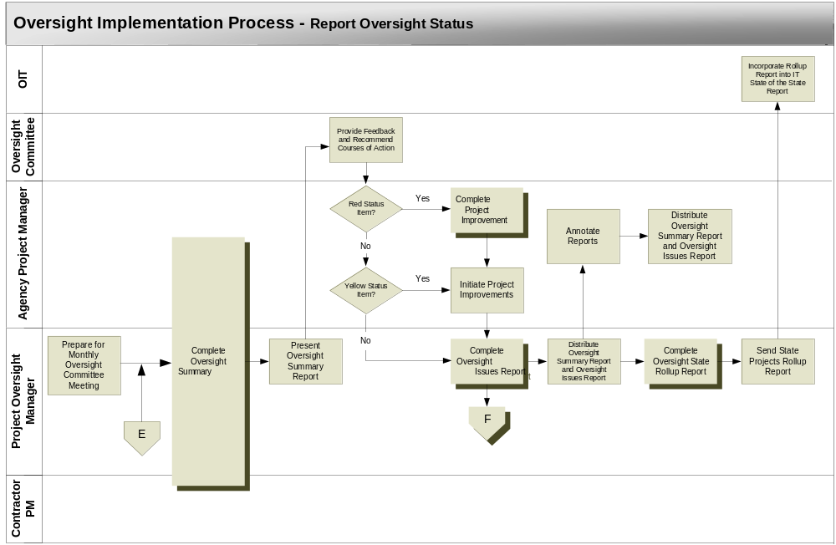

Report Oversight Status

This sub-process is triggered by:

- The monthly oversight status reporting cycle

This sub-process description assumes the use of an oversight committee. Though there will be many projects without oversight committees, for clarity sake this assumption was made. For those projects without an oversight committee, an Oversight Reviewer can be substituted. The primary project stakeholder (Usually an upper level agency manager) typically fills this role, which is described in the roles and responsibilities section of the MPOP Manual, Part I.

The oversight manager is responsible for reporting status on three different levels to three different audiences, the agency project manager, the oversight committee or oversight reviewer, and the Office of Information Technology. There are also three different tools for reporting this status:

- Oversight Summary Report
- Oversight Issues Report
- Oversight Projects Rollup Report

The Oversight Summary Report is intended for the Oversight Committee and is presented at the regularly scheduled oversight committee meetings. It is focused on the overall health of the project at a relatively high level. The Oversight Issues Report is a report that summarizes the areas of concern generated when developing the Oversight Committee Status Report. It provides additional status detail, a listing of issues from the oversight committee meeting, and recommended courses of action. The Oversight State Projects Rollup Report is a very high level report intended for the OIT. It provides a summary view of all IT projects across the state to which project oversight is applied.

Complete Oversight Summary Report – Using the report example as a guide, the oversight manager can generate the Oversight Summary Report.

Present Oversight Summary Report – The oversight manager will provide a presentation of oversight status during the oversight committee meeting.

Provide Feedback and Recommended Courses of Action – The oversight committee meeting will include a discussions of high risk issues and potential actions. The oversight committee is a managerial body that helps provide direction to the project. As such it may provide recommended courses of action for all issues.

Complete Project Improvement Plan Template – In the case of a red status item, the oversight committee will require that a Project Improvement Plan be developed. Completion of this template by the agency project manager will help ensure that all improvement plan information will be provided.

Initiate Project Improvements – The improvement plan will provide steps necessary to resolving the issue. The agency project manager distributes the improvement plan to the responsible party and ensures that the improvements are initiated. The agency project manager also initiates project improvements in the event of a yellow status item.

Complete Oversight Issues Report - Using the report example as a guide, the oversight manager can generate the Oversight Issues Report. This report is then used to track and monitor status of issues during the time span between oversight committee meetings.

Distribute Oversight Summary Report and Oversight Issues Report – Once completed, the Oversight Summary Report and the Oversight Issues Report are distributed to all project stakeholders.

Complete Oversight Projects Rollup Report - Using the report example as a guide, the oversight manager can generate the Oversight State Projects Rollup Report. It will help ensure all necessary information is included in the report.

Incorporate Rollup Report into IT State of The State Report – The Missouri Office of Information Technology (OIT) will incorporate the status provided via the Oversight State Projects Rollup Report. This will provide OIT with a strong sense of the health of all IT project across all state agencies.
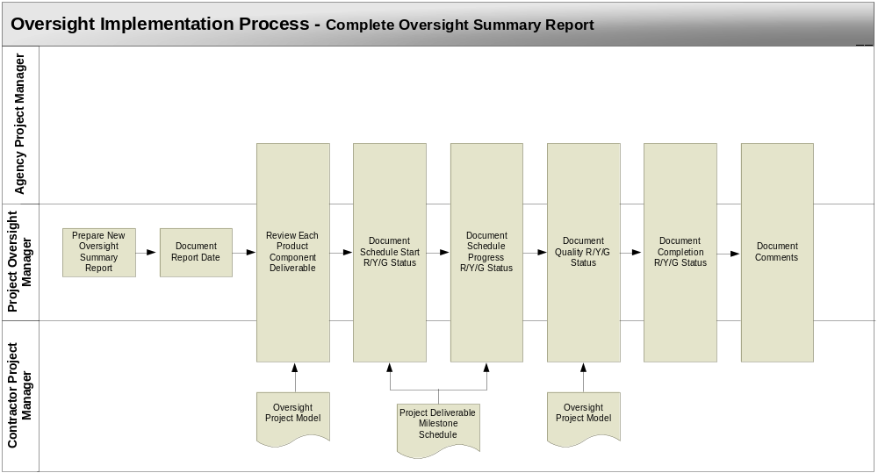

Complete Oversight Summary Report

Once a month, designated project stakeholders meet to discuss project status at the oversight committee meetings. These meetings are a key element in the oversight process. It is from them that much of the project improvement is initiated. The oversight committee membership is comprised primarily of high-level management staff representing various organizations with a stake in the project. As stakeholders, these participants have a high level of vested interest in the success of the project. The monthly oversight meetings provide the opportunity for them to participate in the overall guidance of the project based upon the reported status.

In preparation for the oversight committee meetings, the Oversight Summary Report is generated. This report is highly effective because it summarizes the project into an easy to discern, single view of the project’s many product and services. This helps to remove much of the complexity. By using color instead of text to indicate status, the overall state of the project health can be assessed at a glance. If details are needed to explain status, this is provided in the OPM and can be provided at the click of a mouse.

The agency project manager, oversight manager and contractor project manager perform a status assessment of the products and services provided in the OPM. The status is updated based upon the following criteria:

- Green - All deliverables are on schedule and have satisfactory quality.
- Yellow – Potential schedule overrun or questionable quality. Special attention in this area can prevent an impact to overall project budget/schedule.
- Red - Overrun on schedule or poor quality. Extensive effort or project scope change is needed to avoid overall project budget/schedule impact. Project Improvement Plan required.

With green status, there are no concerns and the project should progress as in the past. Yellow status indicates a potential problem that should be addressed before it grows into a more pressing issue. Red status indicates a major problem with either schedule or quality.

To ensure that red status issues are addressed, the oversight committee requires that a Project Improvement Plan be assigned to the person responsible for the product, service or deliverable in red status. The improvement plan is a mechanism to initiate the actions taken to find a solution that will remedy the red status. It also ensures accountability.

Yellow status does not require an improvement plan. This is due to the fact that stepped-up normal activities will normally remedy the situation without any special effort.

Generating status inputs to the monthly Oversight Summary Report involves a status review meeting attended by the oversight manager, agency project manager, and contractor project manager (if applicable) . The purpose of this meeting is to collect the current oversight status, record the status in the Oversight Summary Report, and prepare for the Oversight Committee Meeting (if applicable).

Using the Oversight Summary Report Example as a guide will help ensure that all important elements of the report are documented. The following process steps will aid in this documentation:

Prepare New Oversight Summary Status Report – In preparation for the oversight status review meeting, the oversight manager creates a new oversight summary status report using the previous months report as a baseline. The status from the previous month’s report will provide a starting point for discussing current status.

Document Report Date – Include the date when the Oversight Summary Report will be presented to either the oversight committee or the oversight reviewer.

Review Each Oversight Project Model Deliverable – For each product component listed in the report, the oversight manager will locate the deliverables for that product component in the OPM. By reviewing the status of each individual deliverable, an overarching status for the entire product component can be determined. Essentially the entire product component takes on the status of the deliverable with the highest level of concern. In other words, if all deliverables are green except for one with red status, then the entire product component will be given red status.

Document Schedule Start R/Y/G Status – Review the start date in the project schedule for all deliverables for each product component. If the deliverable actual start date was on or before the scheduled start date, then the status will be green. If the start date has passed and the deliverable has not been started, this is an indicator of a potential schedule impact. The status indicator is set to yellow or red according to the status criteria provided above. Once all deliverables are reviewed, determine the final status for the product component.

Document Schedule Progress R/Y/G Status – Review the deliverable’s scheduled dates to determine how much progress is expected at a point in time. Obtain current status of actual progress from the agency project manager. If the actual progress is at or beyond the expected progress, then the deliverable status will be green. If actual progress is behind expected progress, this is an indicator of a potential schedule impact. The status indicator is set to yellow or red according to the status criteria provided above. Once all deliverables are reviewed, determine the final status for the product component.

Document Quality R/Y/G Status – The quality status indicator is set according to two factors. First, the review of deliverable quality utilizing the OPM quality points (See the Evaluate Deliverable Quality sub-process) may provide issues that will affect the status indicator setting. Second, general issues regarding contractor performance, deliverable accuracy, budget issues, project management issues, etc. may also affect the setting. Once all deliverables are reviewed, determine the final status for the product component.

Document Completion R/Y/G Status – This is a special status item intended to provide an indication of completion. If all deliverables of a particular product component are complete, then this indicator turns green. This indicator will only turn yellow or red if it has been determined that a deliverable(s) will be difficult or impossible to delivery without changes in the project. Once all deliverables are reviewed, determine the final status for the product component.

Document Comments - The comment column of the report provides a means to annotate the status giving added detail about the specific deliverable with yellow or red status that has caused the overall product component status to turn yellow or red. These comments provide specific detailed information that is reported at the oversight committee meeting and is included in the Oversight Issues Report (See the Report Oversight Status sub-process).

Oversight Summary Report Example

Report Overview

This sample report is to be used as a guide to developing the Oversight Summary Report. This report will be used to report an oversight summary of project status. The example provides the exact format needed for any Oversight Summary Report.

Report Sections

The Oversight Summary Report includes the following sections:

Report Date
Product/Service
Component
Deliverable Schedule “Start on Time”
Deliverable Schedule “Progress”
Deliverable Quality
Component Complete
Comments

Report Example

The Oversight Summary Report provides a vehicle for documenting the oversight summary status information in an electronic format as a Microsoft Excel file. The visual representation of the Oversight Summary Report Example, provided here, is followed by the detailed description of its contents. The oversight manager may access MPOP Oversight Summary Report Example.xls for electronic entry of the Oversight Summary Report detail.
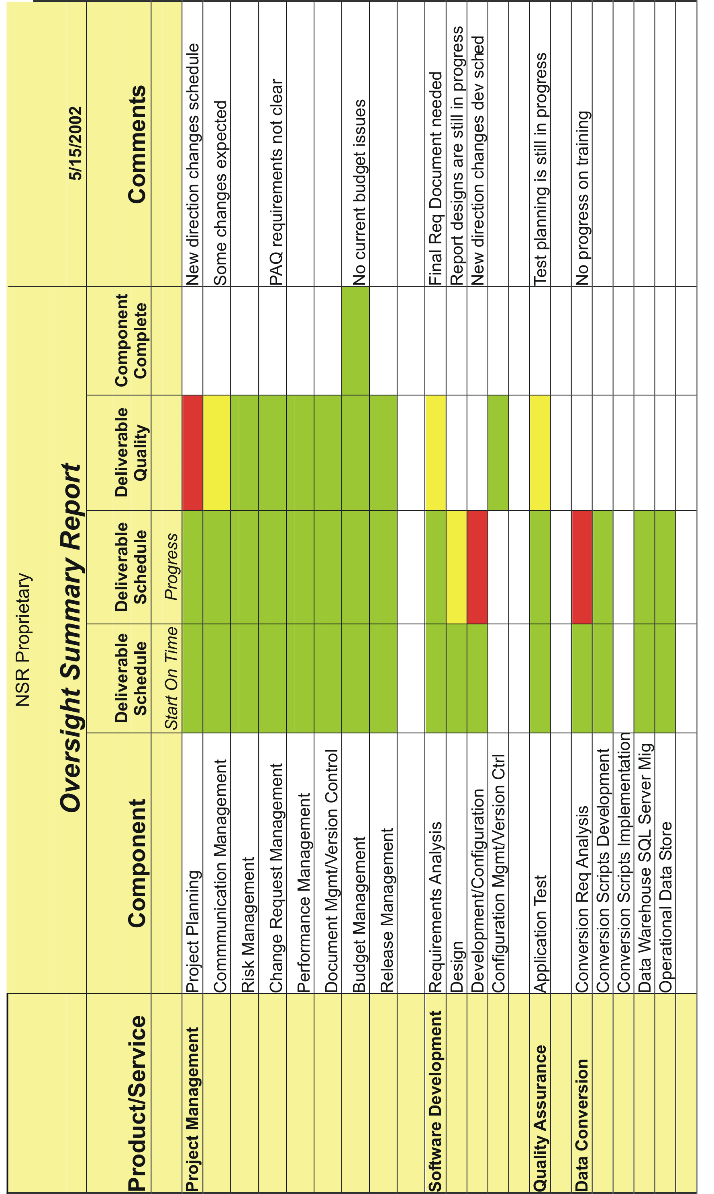
Oversight Summary Report Example

Report Detail

Section I – Report Date
The date the Oversight Summary Report is presented.

Section II – Product/Service
The name of each product/service identified for the project and listed in the OPM.

Section III – Component

The name of each product component identified for each product/service and listed in the OPM.

Section IV – Deliverable Schedule “Start on Time”
The column used to indicate R/Y/G status for the timeliness of starting the deliverable development.

Section V – Deliverable Schedule “Progress”
The column used to indicate R/Y/G status for deliverable schedule progress.

Section VI – Deliberable Quality

The column used to indicate R/Y/G status for deliverable quality.

Section V – Component Complete
The column used to indicate R/Y/G status for completion of all deliverables categorized under a single component.

Section VI – Comments

The column used to provide specific detailed descriptions of the issues surrounding a deliverable that have caused a change in status or a continued status of red or yellow.

